
Naan Mudhalvan (NM)
Salesforce CRM Development Track
A CRM Application for The Chai Shop & Co
A Salesforce-Based Customer Relationship Management System
Field | Details
Project Title | A CRM Application for The Chai Shop & Co
Team Name | Naan Mudhalvan Team 4
Team ID | SWTID-2026-7097
College | Islamiah Women’s Arts and Science College
Course | Naan Mudhalvan (NM) — SmartBridge

S.No | Name | Role | SmartBridge / Skill Wallet Student ID
1 | Moolai Riza Fathima | Team Leader | SWUID2026328654
2 | Bushra Umme Kulsoom | Team Member | SWUID2026330374
3 | Labina Mariyam .K | Team Member | SWUID2026330370
4 | Moolai Aleena Maryam | Team Member | SWUID2026330362
5 | Shahiya Saliqua .A | Team Member | SWUID2026330347


A SmartBridge Product
Academic Year: 2026 – 2027

Table of Contents
User Story 3
1. Introduction 4
1.1 Project Overview 4
1.2 Purpose 4
2. Ideation Phase 5
2.1 Problem Statement (Customer Problem Statement Template) 5
2.2 Empathy Map Canvas 5
2.3 Brainstorming 5
3. Requirement Analysis Phase 6
3.1 Customer Journey Map 6
3.2 Solution Requirements 6
3.3 Data Flow Diagram 8
3.4 Technology Stack 8
4. Project Design Phase 9
4.1 Problem-Solution Fit 9
4.2 Proposed Solution 9
4.3 Solution Architecture 10
5. Project Planning & Scheduling 11
5.1 Project Planning 11
5.2 Planning Principles 11
5.3 Product Backlog & Sprint Schedule 12
5.4 Project Tracker & Sprint Control 13
5.5 Sprint Lifecycle 13
5.6 Estimation & Velocity + Burndown Tracking 13
5.7 Planning Summary + Key Deliverables 14
6. Project Development Phase 15
6.1 Project Flow 15
6.2 What You'll Learn 15
6.3 Implementation: Milestone Summary 15
6.4 CRM Implementation Architecture 20
6.5 Development Outcome 20
6.6 Final Milestone Checklist 20
7. Functional & Performance Testing 21
7.1 Functional Testing 21
7.2 Performance Testing 22
8. Advantages & Disadvantages 23
8.1 Advantages 23
8.2 Disadvantages 23
9. Conclusion 24
10. Future Scope 25
11. Appendix 26
Thank You 27

User Story
As a sales representative at The Chai Shop & Co, I need one dependable CRM workspace where I can look after our customers and keep every sale on track.
- I want to open and update employer details quickly, and to tell online orders apart from walk-in orders through dedicated record types, so I can serve each customer in the way that suits them.
- I want the system to work out order quantity and the total bill by itself, so that every transaction is accurate and I never have to do the arithmetic by hand.
- I want ready-made reports and dashboards that turn raw sales figures into clear pictures, so that I and the management team can make better decisions and plan our strategy.
- I want the application to send each customer a birthday email with a special offer, so that our customers feel remembered and keep coming back.

1. Introduction

1.1 Project Overview
The project "A CRM Application for The Chai Shop & Co" develops a Salesforce-based Customer Relationship Management (CRM) system that manages customer, employer, and enterprise accounts efficiently. The system automates sales processes, maintains accurate customer records, generates reports and dashboards, and improves customer engagement through automated notifications.
The user story and project objectives are defined at the beginning of this document.

1.2 Purpose
The purpose of this project is to:
- Streamline customer relationship management
- Automate billing and order calculations
- Improve data accuracy
- Enable data-driven decision-making
- Enhance customer engagement through email automation

2. Ideation Phase

2.1 Problem Statement (Customer Problem Statement Template)
PS | I am (Customer) | I'm trying to | But | Because | Which makes me feel
PS-1 | Sales Representative | Record customer orders and prepare accurate bills | The totals I produce frequently turn out wrong | Quantities and bill amounts have to be worked out by hand | Under pressure and unproductive
PS-2 | Store Manager | Keep track of sales performance and customer information | The reports I receive arrive late and leave gaps | Information is scattered across several separate files | Uncertain and unhappy with the process
PS-3 | Customer | Receive offers and updates that feel personal to me | Messages from the shop rarely reach me on time | The shop has no automated way of contacting customers | Overlooked and unappreciated

2.2 Empathy Map Canvas
Target Users
- Sales Representatives
- Managers
- System Administrators
- Business Analysts
Empathy Analysis
Aspect | Description
Think & Feel | Need accurate customer data and reports
Hear | Feedback from management
See | Multiple registers and spreadsheets
Say & Do | Enter data manually
Pain | Errors, delays, data loss
Gain | Automation, fast reports

2.3 Brainstorming
Brainstormed Ideas
- Manual CRM system
- Excel-based management
- Web-based CRM
- Salesforce-based CRM
- Automated email system
Selected Idea
A Salesforce-based CRM Application for The Chai Shop & Co, combined with an automated email system for customer communication.

3. Requirement Analysis Phase

3.1 Customer Journey Map
Journey Stages
Stage | Activity | Outcome
1. Login | The user signs in to Salesforce with valid credentials | Secure access to the org
2. Access CRM Application | The user opens The Chai Shop & Co Lightning App | All CRM objects are available in one workspace
3. Enter Customer Data | Customer, employer, and enterprise details are captured | Complete, validated records
4. Generate Orders | Order items are selected for online or walk-in customers | Orders are stored under the correct record type
5. Calculate Bills | Formula fields compute order quantity and total bill | Accurate billing with no manual effort
6. View Reports | Sales and customer reports are run | Clear, current sales information
7. Decision Making | Managers review dashboards | Informed business decisions

3.2 Solution Requirements
Functional Requirements
FR No | Requirement | Description
FR-1 | User Login | Authorized users sign in securely to the Salesforce org
FR-2 | Object Creation | Employer, Customer, and Enterprise custom objects store business data
FR-3 | Data Entry | Users enter and update records through page layouts and record types
FR-4 | Billing Automation | Formula fields calculate order quantity and total bill
FR-5 | Report Generation | Reports and dashboards summarize sales and customer data
FR-6 | Email Automation | Flows send birthday offer emails to customers automatically

Non-Functional Requirements

NFR-1: Usability
The system should be easy to use for sales representatives, managers, administrators, and analysts without requiring technical training.
Requirements:
- Simple and intuitive user interface
- Clear navigation menus
- Easy-to-understand forms
- User-friendly dashboards
Example: A new sales employee should be able to log in, enter customer details, and generate orders within a few minutes without help. The Salesforce Lightning UI provides drag-and-drop features and easy navigation.

NFR-2: Security
The system must protect customer and business data from unauthorized access.
Requirements:
- Role-based access control
- Secure login authentication
- Encrypted data storage
- Data backup and recovery
Examples:
- Profiles and permission sets
- Object-level and field-level security
- Restricted billing access
- Secure login and password policies

NFR-3: Reliability
The CRM system should work correctly at all times and store data accurately without loss.
Requirements:
- Automatic data saving
- Regular system backups
- Error handling mechanisms
- Stable cloud environment
Example: If a user enters order data and the internet disconnects, the system should save the information and restore it later. The Salesforce cloud provides automatic backups.

NFR-4: Performance
The system should respond quickly and handle large amounts of data efficiently.
Requirements:
- Fast page loading
- Quick report generation
- Smooth dashboard rendering
- Minimal delay
Example: When a manager generates monthly sales reports for hundreds of customers, the report should load within 2–3 seconds. Optimized queries and caching improve speed.

NFR-5: Availability
The system should be accessible whenever required.
Requirements:
- 24/7 system availability
- Minimal downtime
- Cloud-based hosting
- Disaster recovery
Example: Managers should be able to access the CRM system during peak business hours, weekends, or late nights. The Salesforce cloud provides high uptime.

NFR-6: Scalability
The system should support business growth without affecting performance.
Requirements:
- Ability to handle more users
- Support for increasing customer data
- Expandable storage
- Consistent system speed
Example: If The Chai Shop & Co expands to multiple branches, the CRM system should support thousands of customers without slowing down. The Salesforce infrastructure scales automatically.

3.3 Data Flow Diagram
The data flows through the system in the following sequence:
User → Salesforce UI → Custom Objects → Validation Rules → Flows → Reports → Dashboards

Stage | Role in the Data Flow
User | Enters and retrieves data through the Lightning interface
Salesforce UI | Presents forms, tabs, and page layouts
Custom Objects | Store Employer, Customer, and Enterprise records (read/update)
Validation Rules | Check the logic and format of entered data
Flows | Automate tasks such as birthday email delivery
Reports | Summarize stored data
Dashboards | Present report results visually for decision-making

3.4 Technology Stack
Layer | Technology
Frontend | Salesforce Lightning
Database | Salesforce Cloud
Automation | Flows
Backend | Salesforce Platform
Analytics | Reports & Dashboards

4. Project Design Phase

4.1 Problem-Solution Fit
The CRM system replaces manual records with automated data management. Cloud storage prevents data loss, dashboards improve analysis, and real-time reports eliminate delays. This ensures accurate and timely business insights.
Problem | Solution
Manual records are prone to errors, delays, and data loss | Cloud storage prevents data loss
Analysis is slow and unreliable | Dashboards improve analysis
Reports arrive late | Real-time reports eliminate delays

4.2 Proposed Solution
Parameter | Description
User Login & Authentication | Allows authorized users to securely log in to the CRM system using valid credentials.
Customer Record Management | Enables users to create, view, update, and delete customer details such as name, contact number, and address.
Employer & Enterprise Management | Allows management of employer and enterprise account information for business operations.
Order Management | Supports creation and tracking of customer orders, including order quantity and product details.
Automated Billing System | Automatically calculates the total bill amount using formula fields based on order quantity and pricing.
Validation Rules | Ensures accurate data entry by validating fields such as phone number, PAN, and Aadhaar.
Record Types & Page Layouts | Provides different record types and layouts for various customer and enterprise categories.
Global Picklists | Maintains standardized values for fields such as product type, category, and payment mode.
Email Notification System | Sends automated emails to customers for birthdays, offers, and order confirmations.
Workflow & Flow Automation | Automates tasks such as updating records and triggering alerts using Salesforce Flows.
Report Generation | Generates detailed reports on sales, customers, and enterprise performance.
Dashboard Visualization | Displays real-time analytics through interactive dashboards and charts.
Data Backup & Recovery | Ensures secure storage and recovery of business data in the Salesforce cloud.
User Role Management | Controls system access using profiles and permission sets for different users.

4.3 Solution Architecture
Architecture Layers
- Presentation Layer: Lightning UI
- Application Layer: Flows and Logic
- Data Layer: Custom Objects
- Analytics Layer: Reports and Dashboards
Design Note
This layered architecture ensures modularity, scalability, and maintainability.

5. Project Planning & Scheduling

5.1 Project Planning
The project followed an Agile-based development approach with defined milestones and sprints. Planning focused on building a structured Salesforce environment, modeling business data, automating routine activities, and delivering useful reports and dashboards within the planned timeline.
# | Planning Area | Planned Activity
01 | Development Setup | Create the Salesforce Developer environment and prepare the project workspace.
02 | Data Modeling | Design Customer, Employer and Enterprise objects, fields, relationships and tabs.
03 | Configuration | Configure page layouts, record types, picklists and validation rules.
04 | Automation | Develop email templates, flows and automated billing/notification processes.
05 | Analytics | Build reports and dashboards for sales, customer and enterprise monitoring.
06 | Sprint Review | Test each increment, review progress, resolve issues and track completion.

Key planning activities:
- A Salesforce Developer account was created to set up the development environment.
- Custom objects were designed to store customer, employer, and enterprise data.
- Custom tabs and a Lightning Application were developed for easy system navigation.
- Fields, relationships, and global picklists were configured to ensure data consistency.
- Page layouts and record types were created based on user roles and customer categories.
- Validation rules were implemented to prevent incorrect data entry.
- Email templates and automated flows were developed for customer notifications.
- Reports and dashboards were created for performance monitoring and analysis.
- Regular sprint reviews and testing were conducted to track progress and resolve issues.
- The project was completed within the planned timeline through systematic scheduling.

5.2 Planning Principles
- Incremental delivery: Functionality was organized into manageable sprints.
- Data consistency: Fields, relationships, picklists and validation rules were planned before automation.
- User-focused design: Layouts, record types and navigation were aligned with different CRM users.
- Continuous review: Sprint reviews and testing were used to identify and resolve issues early.

Planned Outcome
A scalable Salesforce CRM environment capable of managing customer, employer and enterprise information while supporting orders, billing, automated communication, reporting and dashboard-based analysis.

5.3 Product Backlog & Sprint Schedule
The backlog translates the project requirements into user stories. Story points indicate relative effort, while priority identifies the order in which work should be addressed.
Sprint | Functional Requirement (Epic) | User Story Number | User Story / Task | Story Points | Priority | Team Member
Sprint-1 | Developer Setup | USN-1 | As an admin, I want to create a Salesforce developer account so that I can configure and deploy the The Chai Shop & Co CRM application. | 1 | High | Moolai Riza Fathima
Sprint-1 | Data Modeling | USN-2 | As an admin, I want to create Customer, Employer, and Enterprise objects so that business data can be stored and managed systematically. | 3 | High | Bushra Umme Kulsoom
Sprint-2 | Data Modeling | USN-3 | As a user, I want separate tabs for each object so that I can easily navigate and manage CRM records within the application. | 3 | High | Labina Mariyam .K
Sprint-2 | Data Modeling | USN-4 | As a manager, I want a dedicated Lightning App so that all CRM operations are accessible from a single workspace. | 3 | High | Moolai Riza Fathima
Sprint-2 | Data Modeling | USN-5 | As an admin, I want to create customer and order fields so that complete sales and billing details can be captured accurately. | 5 | Medium | Moolai Aleena Maryam
Sprint-2 | Data Modeling | USN-6 | As a user, I want customized page layouts for different record types so that only relevant information is displayed during data entry. | 5 | High | Shahiya Saliqua .A
Sprint-2 | Data Modeling | USN-7 | As a manager, I want separate record types for Retail and Enterprise customers so that different business categories can be managed efficiently. | 5 | Medium | Bushra Umme Kulsoom
Sprint-3 | Automation | USN-8 | As a system, I want to validate customer details and order inputs so that incorrect data entries are prevented. | 3 | High | Labina Mariyam .K
Sprint-3 | Automation | USN-9 | As a system, I want automated flows to send email notifications so that customers receive timely updates and offers. | 5 | High | Moolai Aleena Maryam
Sprint-4 | Automation | USN-10 | As a system, I want to automatically calculate billing amounts so that invoices are generated without manual effort. | 5 | High | Shahiya Saliqua .A
Sprint-5 | Reports | USN-11 | As a manager, I want sales and customer reports so that I can monitor business performance and make informed decisions. | 4 | High | Bushra Umme Kulsoom
Sprint-6 | Dashboards | USN-12 | As a manager, I want visual dashboards so that I can quickly analyze sales, customers, and enterprise performance. | 4 | Medium | Moolai Riza Fathima

Workload distribution
Team Member | Role | User Stories Owned
Moolai Riza Fathima | Team Leader | USN-1, USN-4, USN-12 (environment setup, application integration, and final dashboard review)
Bushra Umme Kulsoom | Team Member | USN-2, USN-7, USN-11
Labina Mariyam .K | Team Member | USN-3, USN-8
Moolai Aleena Maryam | Team Member | USN-5, USN-9
Shahiya Saliqua .A | Team Member | USN-6, USN-10

Backlog Structure
The backlog moves from environment setup and data modeling toward automation and analytics. This sequence reduces dependency issues, because reporting and dashboards are built only after the underlying CRM data and processes are established.

5.4 Project Tracker & Sprint Control
The sprint tracker gives a compact view of planned effort, timing and completion. The original schedule defines six sprints in the backlog, while the tracker below records the first four sprint windows supplied in the project plan.
Sprint | Total Story Points | Duration | Sprint Start Date | Sprint End Date (Planned) | Story Points Completed (as on Planned End Date) | Sprint Release Date (Actual)
Sprint-1 | 20 | 6 Days | 01 Oct 2026 | 06 Oct 2026 | 20 | 06 Oct 2026
Sprint-2 | 20 | 6 Days | 07 Oct 2026 | 12 Oct 2026 | — | —
Sprint-3 | 20 | 6 Days | 13 Oct 2026 | 18 Oct 2026 | — | —
Sprint-4 | 20 | 6 Days | 19 Oct 2026 | 24 Oct 2026 | — | —

5.5 Sprint Lifecycle
Plan | Build | Test | Review | Release
Select stories and estimate effort | Configure and develop | Validate behaviour and data | Review progress and issues | Deliver the completed increment

5.6 Estimation & Velocity + Burndown Tracking
Estimation & Velocity
Story points provide a relative measure of work rather than a direct time estimate. As sprints progress, completed story points can be used to observe team velocity and improve future planning.
- Each planned sprint carries a target of 20 story points over a 6-day window.
- Sprint-1 delivered all 20 planned points by its planned end date, which gives a velocity of 20 points per sprint (about 3.3 points per day).
- This velocity serves as the baseline for planning later sprints.
Burndown Tracking
A burndown chart plots the remaining story points against the sprint timeline. A downward trend toward zero indicates progress toward the planned sprint scope. Comparing the actual line with the ideal line at each sprint review helps the team spot delays early and rebalance work among members.

5.7 Planning Summary + Key Deliverables
From Requirements to Delivery
The planning phase converts CRM requirements into an organized development roadmap. It establishes what needs to be built, who owns each user story, how much effort is expected, and when each increment is scheduled.
Area | Summary
Requirements | Functional needs are converted into user stories and measurable tasks.
Schedule | Work is grouped into sprints with planned start and end dates.
Ownership | Each story is assigned to a team member for accountability.
Quality | Testing and sprint reviews are included throughout development.

Key Deliverables
- Salesforce development environment
- Customer, Employer and Enterprise data model
- Custom tabs, Lightning App, fields and relationships
- Page layouts, record types and global picklists
- Validation rules, email templates and automated flows
- Reports and dashboards for CRM analysis

Planning Phase Complete
The project plan establishes a clear path from setup and data modeling to automation, reporting and dashboard delivery.

6. Project Development Phase
The development phase converts the planned CRM design into a working Salesforce application. Implementation is organized as a sequence of milestones, beginning with the developer environment and progressing through objects, navigation, configuration, automation, reporting and dashboards.

6.1 Project Flow
Milestone | Stage | Purpose
01 | Developer Account | Create and activate the Salesforce development environment.
02 | Object Creation | Create Employer, Customer and Enterprise custom objects.
03 | Tabs | Create custom tabs for easy navigation.
04 | Lightning App | Bring CRM operations together in a dedicated application.
05 | Global Picklist | Standardize repeated values across CRM fields.
06 | Fields & Relationships | Define the information captured and how records connect.
07 | Page Layouts | Control which fields and sections users see.
08 | Record Types | Support different customer or enterprise categories.
09 | Validation Rules | Prevent inaccurate or incomplete data entry.
10 | Email Templates | Prepare reusable customer communication templates.
11 | Flows | Automate notifications, updates and business processes.
12 | Reports & Dashboards | Turn CRM data into monitoring and analysis tools.
13 | Conclusion | Review the completed CRM solution and outcomes.

6.2 What You'll Learn
- Real-time Salesforce project workflow
- Standard and custom objects
- Picklist value sets
- Types of fields and relationships
- Page layouts
- Record types
- Validation rules
- Email templates
- Flows
- Reports and dashboards

6.3 Implementation: Milestone Summary

Milestone 1: Developer Account Creation
- Signed up for a free Salesforce Developer Edition org using first and last name, email, Role as Developer, college/company name, country (India), postal code, and a unique username in email format.
- Activated the account through the verification email (which can take 5–10 minutes to arrive), then set a password and security question.
- The user was redirected to Salesforce Setup, which confirmed that the development environment was ready.
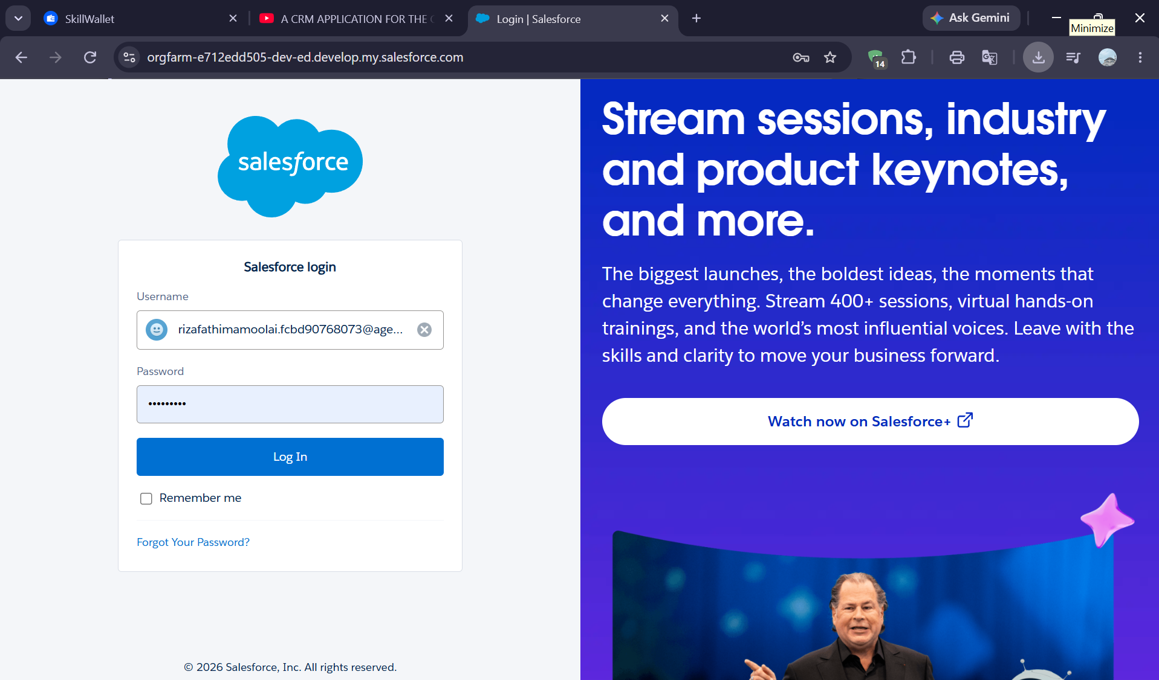

Milestone 2: Objects (Employer, Customer, Enterprise)
- Opened Setup → Object Manager → Create → Custom Object for each of the three objects.
- Created Employer Account, Customer Account and Enterprise Account, each with a Text-type record name (e.g. "Employer Account Name").
- Enabled Allow Reports, Allow Activities and Track Field History on every object, and turned on Allow Search.
- Outcome: three data containers for employer, customer and enterprise information.
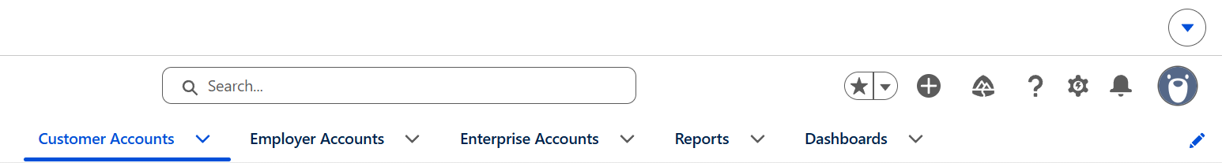

Milestone 3: Tabs
- Opened Setup → Tabs and selected New under Custom Object Tabs.
- Created a custom tab for Employer Accounts, Customer Accounts and Enterprise Accounts, choosing a tab style for each.
- Kept the default profile visibility and the option to append tabs to users' existing personal customizations.
- Outcome: direct navigation points to all three objects.

Milestone 4: The Lightning App
- Created a new Lightning App named The Chai Shop & Co from App Manager.
- Selected Standard navigation, the Setup experience, and Desktop and Phone form factors, with the default utility bar alignment.
- Added Customer Accounts, Employer Accounts, Enterprise Accounts, Reports and Dashboards as navigation items.
- Granted access to the System Administrator profile.
- Outcome: a single workspace for all CRM operations.
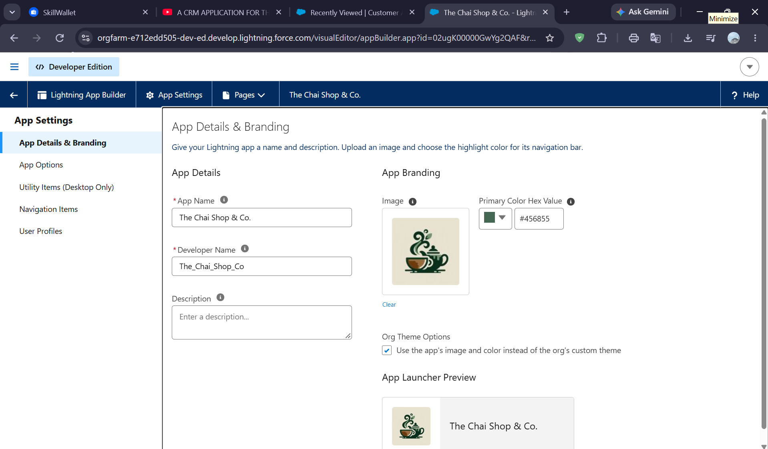

Milestone 5: Global Picklist
- Created four global picklist value sets from Setup → Picklist Value Sets.
- Gender: Male, Female, Others.
- Items: 17 products, covering tea powders, Osmania and other biscuits, cookies, and gift boxes (e.g. Platinum Tea Powder, Ragi Biscuits, Butter Almond Cookies, Signature Box).
- Payment Mode: Gpay, PhonePe, Paytm, Credit or Debit card, Cash.
- Type of Items: Tea powder, Cookies, Gift Hampers.
- Outcome: standardized, reusable values shared across objects.

Milestone 6: Fields & Relationships
- Employer Account fields: First Name, Last Name, Gender (global picklist), Phone Number, Email ID, Date of Birth, Aadhar Number (12 characters), PAN Details (10 characters), Designation (picklist: Manager, Finance and Accounting, Kitchen Staff, Cashier, Servers) and Salary (currency).
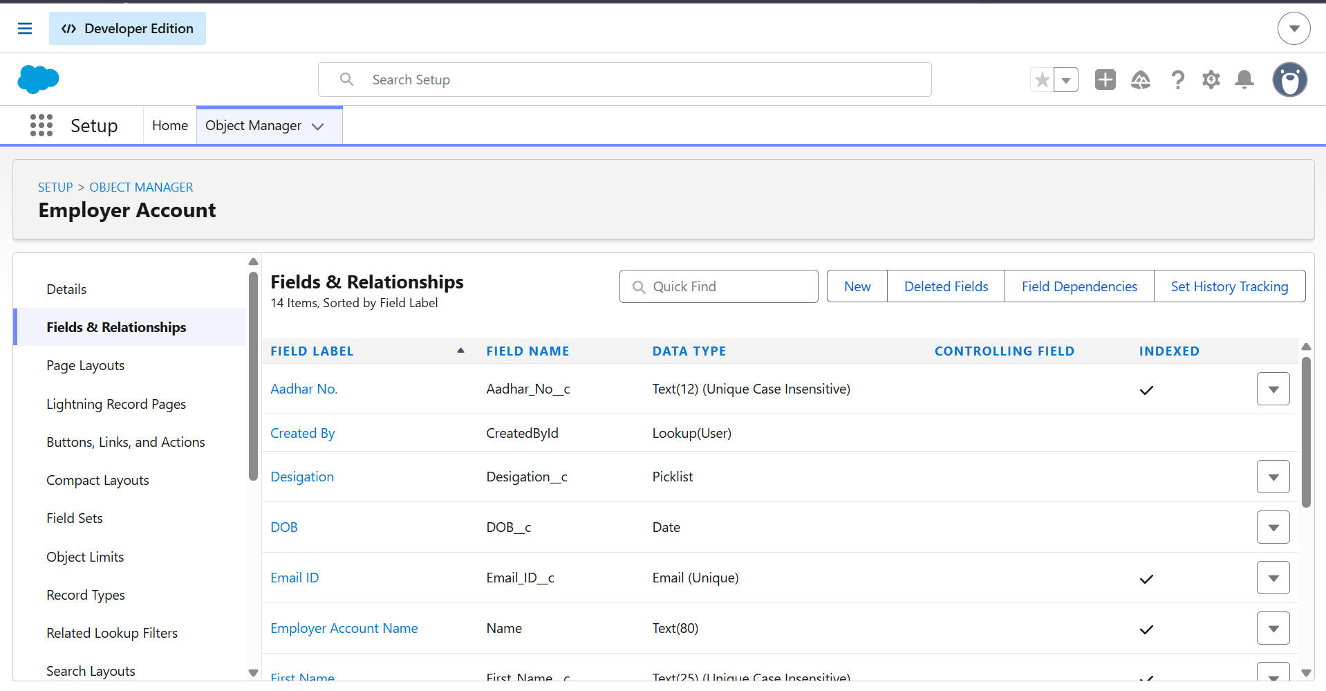
- Customer Account fields: First Name, Last Name, Gender, Phone Number, Date of Birth, Email ID, Address, Type of Items and Products Purchased (multi-select picklists from global sets), Chai (multi-select picklist of seven tea varieties), and Payment Mode.
- Relationship: a Lookup field, Associated Employer, links Customer and Enterprise records to Employer Account.
- Formula fields:
  - Date of Birthday is today? (Checkbox) drives the birthday automation.
  - Order Quantity (Number) counts the items selected.
  - Total Bill (Number) sums the price of each selected item.
- Enterprise Account fields: Enterprise Name, Phone Number, Email ID, Address, Type of Items, Products Purchased, Associated Employer (lookup), Payment Mode, plus Order Quantity and Total Bill formulas without the Chai terms.
Birthday check formula (Customer Account):
IF(
AND(
DAY( TODAY() ) = DAY( Date_of_Birth__c ),
MONTH( TODAY() ) = MONTH( Date_of_Birth__c )
),
TRUE,
FALSE
)

Order Quantity formula (Customer Account):
IF(INCLUDES( Products_Purchased__c , "Platinum Tea Powder"), 1, 0 ) +
IF(INCLUDES( Products_Purchased__c , "Double Delight Tea Powder"), 1, 0 ) +
IF(INCLUDES( Products_Purchased__c , "Super Dust Tea Powder"), 1, 0 ) +
IF(INCLUDES( Products_Purchased__c , "Osmania Biscuits (Value Pack)"), 1, 0 ) +
IF(INCLUDES( Products_Purchased__c , "Osmania Biscuits (Premium Pack)"), 1, 0 ) +
IF(INCLUDES( Products_Purchased__c , "Dry Fruit Biscuits"), 1, 0 ) +
IF(INCLUDES( Products_Purchased__c , "Fruit Biscuits"), 1, 0 ) +
IF(INCLUDES( Products_Purchased__c , "Salt Biscuits"), 1, 0 ) +
IF(INCLUDES( Products_Purchased__c , "Multigrain Biscuits"), 1, 0 ) +
IF(INCLUDES( Products_Purchased__c , "Ragi Biscuits"), 1, 0 ) +
IF(INCLUDES( Products_Purchased__c , "Double Choco chip Cookies"), 1, 0 ) +
IF(INCLUDES( Products_Purchased__c , "Butter Almond Cookies"), 1, 0 ) +
IF(INCLUDES( Products_Purchased__c , "Melting Moments Cookies"), 1, 0 ) +
IF(INCLUDES( Products_Purchased__c , "Honey Oats Cookies"), 1, 0 ) +
IF(INCLUDES( Products_Purchased__c , "Delight Box"), 1, 0 ) +
IF(INCLUDES( Products_Purchased__c , "Signature Box"), 1, 0 ) +
IF(INCLUDES( Products_Purchased__c , "Assorted Box"), 1, 0 ) +
IF(INCLUDES( Chai__c , "The Chai Shop & Co Special Tea"), 1, 0 ) +
IF(INCLUDES( Chai__c , "Single Tea"), 1, 0 ) +
IF(INCLUDES( Chai__c , "Masala Tea"), 1, 0 ) +
IF(INCLUDES( Chai__c , "Lemon Tea"), 1, 0 ) +
IF(INCLUDES( Chai__c , "Ginger Tea"), 1, 0 ) +
IF(INCLUDES( Chai__c , "Green Tea"), 1, 0 ) +
IF(INCLUDES( Chai__c , "Sugar Free Tea"), 1, 0 )

Total Bill formula (Customer Account):
IF(INCLUDES( Products_Purchased__c , "Platinum Tea Powder"), 175, 0 ) +
IF(INCLUDES( Products_Purchased__c , "Double Delight Tea Powder"), 150, 0 ) +
IF(INCLUDES( Products_Purchased__c , "Super Dust Tea Powder"), 125, 0 ) +
IF(INCLUDES( Products_Purchased__c , "Osmania Biscuits (Value Pack)"), 50, 0 ) +
IF(INCLUDES( Products_Purchased__c , "Osmania Biscuits (Premium Pack)"), 80, 0 ) +
IF(INCLUDES( Products_Purchased__c , "Dry Fruit Biscuits"), 110, 0 ) +
IF(INCLUDES( Products_Purchased__c , "Fruit Biscuits"), 160, 0 ) +
IF(INCLUDES( Products_Purchased__c , "Salt Biscuits"), 110, 0 ) +
IF(INCLUDES( Products_Purchased__c , "Multigrain Biscuits"), 170, 0 ) +
IF(INCLUDES( Products_Purchased__c , "Ragi Biscuits"), 190, 0 ) +
IF(INCLUDES( Products_Purchased__c , "Double Choco chip Cookies"), 200, 0 ) +
IF(INCLUDES( Products_Purchased__c , "Butter Almond Cookies"), 110, 0 ) +
IF(INCLUDES( Products_Purchased__c , "Melting Moments Cookies"), 150, 0 ) +
IF(INCLUDES( Products_Purchased__c , "Honey Oats Cookies"), 160, 0 ) +
IF(INCLUDES( Products_Purchased__c , "Delight Box"), 850, 0 ) +
IF(INCLUDES( Products_Purchased__c , "Signature Box"), 1500, 0 ) +
IF(INCLUDES( Products_Purchased__c , "Assorted Box"), 600, 0 ) +
IF(INCLUDES( Chai__c , "The Chai Shop & Co Special Tea"), 70, 0 ) +
IF(INCLUDES( Chai__c , "Single Tea"), 50, 0 ) +
IF(INCLUDES( Chai__c , "Masala Tea"), 60, 0 ) +
IF(INCLUDES( Chai__c , "Lemon Tea"), 40, 0 ) +
IF(INCLUDES( Chai__c , "Ginger Tea"), 55, 0 ) +
IF(INCLUDES( Chai__c , "Green Tea"), 45, 0 ) +
IF(INCLUDES( Chai__c , "Sugar Free Tea"), 55, 0 )

Milestone 7: Page Layouts (Online Orders, Walk-In Orders)
- Created two page layouts on the Customer Account object from Object Manager → Page Layouts → New.
- Online Orders layout: organized into Customer Details, Order Details and Employer Details sections, with Order Quantity and Total Bill shown in Order Details.
- Walk-In Orders layout: uses the same sections, and additionally shows the Chai selection and Payment Mode for in-store sales.
- Outcome: users see only the fields relevant to each order channel during data entry.

Milestone 8: Record Types (Online Order, Walk-In Order)
- Created two active record types on Customer Account, both based on the Master record type.
- Online Order is assigned the Online Orders page layout for all profiles.
- Walk-In Order is assigned the Walk-In Orders page layout for all profiles.
- Outcome: customer records are separated by order channel, which also allows reports to group sales by record type.

Milestone 9: Validation Rules (Aadhar, PAN, Phone on Employer / Customer / Enterprise)
- Employer Account: created three rules for Aadhar Number, PAN Number and Phone Number, each displaying its error at the top of the page.
  - The Aadhar rule requires exactly 12 numeric digits that never start with 0.
  - The PAN rule requires a non-blank value in the standard 10-character PAN format: five capital letters, four digits, and one capital letter (for example, ABCDE1234F).
  - The Phone rule requires exactly 10 numeric digits with no spaces, dashes or brackets.
- Customer Account and Enterprise Account: created a Phone Number validation rule on each, using the same 10-digit logic.
- Outcome: incorrect or incomplete identity and contact data is rejected at the time of entry.
Aadhar Number rule (Employer Account):
AND(
NOT(ISBLANK( Aadhar_Number__c )),
LEN( Aadhar_Number__c ) <> 12,
NOT(REGEX( Aadhar_Number__c , "^[1-9]{12}$"))
)

PAN Number rule (Employer Account, field PAN_Details__c):
OR(
ISBLANK( PAN_Details__c ),
NOT(REGEX( PAN_Details__c , "^[A-Z]{5}[0-9]{4}[A-Z]{1}$"))
)

Phone Number rule (Employer, Customer and Enterprise Accounts):
AND(
NOT(ISBLANK( Phone_Number__c )),
NOT(REGEX( Phone_Number__c , "^[1-9]{10}$")),
NOT(REGEX( Phone_Number__c , "^\\d+$"))
)

Milestone 10: Email Template + Email Alert (Birthday Offer)
- Created a Text Classic Email Template named Birthday Offer Email in the Unfiled Public Classic Email Templates folder, marked available for use.
- The subject line is "Special Birthday Offer Inside!". The body greets the customer by first name through the merge field {!Customer_Account__c.First_Name__c}.
- The email offers 50% off the next purchase, redeemable with the code HBDAY50, and is signed off by The Chai Shop & Co.
- Created an Email Alert named Happy Birthday email alert on Customer Account using this template. The recipient is the customer's Email ID field and the sender is the default workflow user's email address.
- Confirmed that a Default Workflow User is assigned under Process Automation Settings so that the alert can be sent.
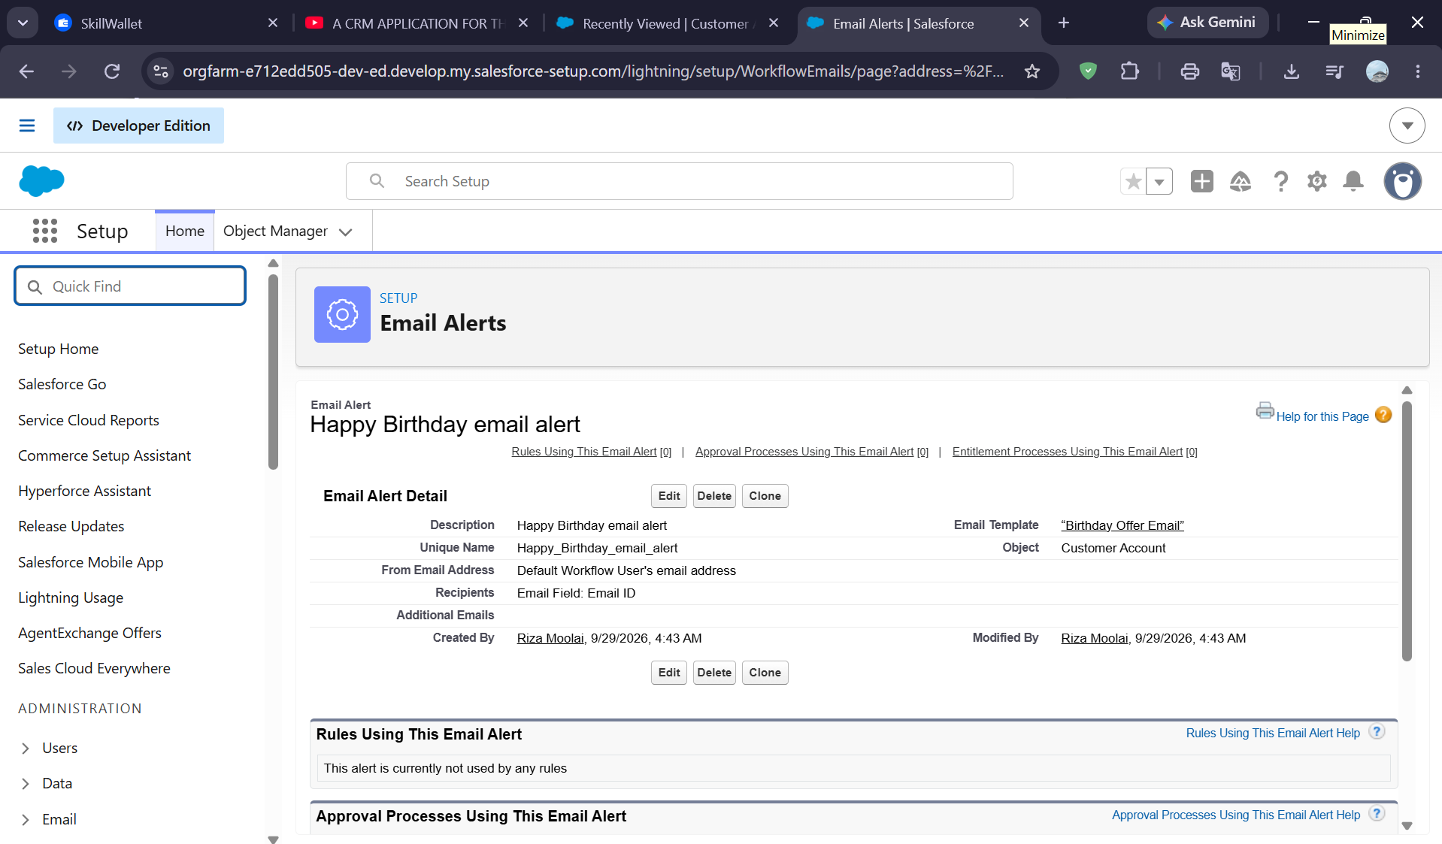

Milestone 11: Flows (Schedule-Triggered Birthday Flow)
- Created a Schedule-Triggered Flow in Flow Builder with a start date and time, running Daily.
- Set the object to Customer Account with all conditions required:
  - Date_of_Birth_is_today__c Equals True
  - Email_ID__c Is Null equals False (the customer must have an email)
- Added an Action element that calls the Happy Birthday email alert, labelled "Send Happy Birthday Email", with Record ID set to {!$Record.Id}.
- Saved the flow as Happy Birthday Email Flow and activated it.
- Outcome: every day, customers whose birthday falls on that date automatically receive the birthday offer email.

Milestone 12: Reports & Dashboards (Customer Sales, Enterprise Sales, Dashboard)
- Customer Account Sales Report: built from the Customer Accounts report type. It shows Type of Items, Products Purchased, Chai, Payment Mode, Order Quantity and Total Bill, grouped by Record Type (Online Order and Walk-In Order), with a chart added.
- Enterprise Account Sales Report: built from the Enterprise Accounts report type. It shows Enterprise Name, Products Purchased, Payment Mode, Order Quantity and Total Bill, grouped by Type of Items, with a chart added.
- Dashboard: created a dashboard named Customer Vs Enterprise Sales with two chart widgets, one per report, and saved it.
- Outcome: management can compare customer and enterprise sales at a glance.

Milestone 13: Conclusion
- The CRM application brings employer, customer (online and walk-in) and enterprise data into one system.
- Automated order quantity and total bill calculations reduce errors, so staff can concentrate on service.
- Automated birthday emails create personal communication and improve customer engagement.
- Reports and dashboards support informed decisions, which completes the planned objectives of the project.
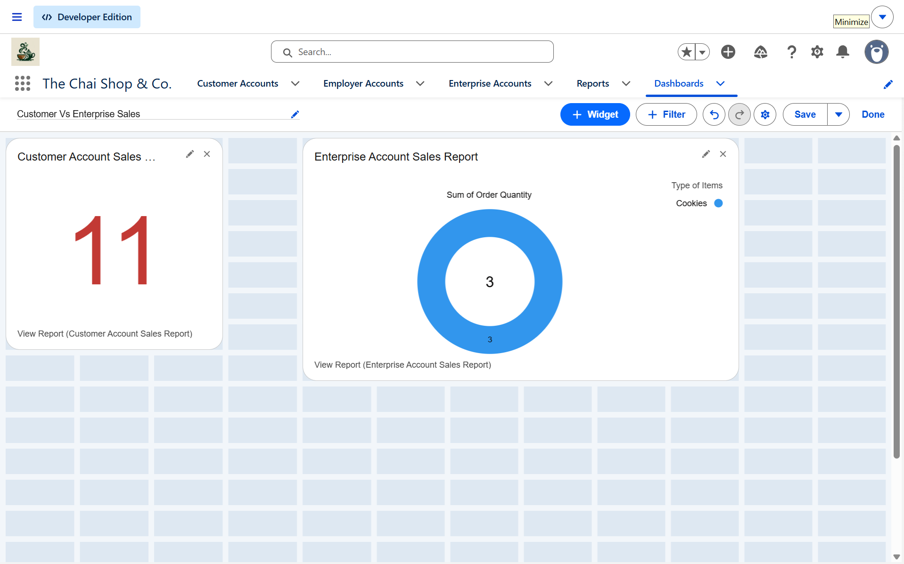

6.4 CRM Implementation Architecture
Presentation | Application | Data | Analytics
Lightning UI | Flows & Logic | Custom Objects | Reports & Dashboards

6.5 Development Outcome
Development Outcome
The completed implementation brings together structured CRM data, controlled user access, consistent data entry, automated workflows, customer communication, and real-time business reporting within Salesforce.

6.6 Final Milestone Checklist
☑ Developer environment
☑ Custom objects
☑ Tabs & Lightning App
☑ Fields & relationships
☑ Page layouts & record types
☑ Validation rules
☑ Email templates & flows
☑ Reports & dashboards

7. Functional & Performance Testing
During the testing phase, screenshots were captured from the Salesforce Lightning interface to verify correct system behavior. The testing covered record creation, validation rules, record types and layouts, formula fields, flow execution, and reports and dashboards.

7.1 Functional Testing
Test ID | Feature Tested | Test Scenario | Expected Result | Result
TC-01 | Record creation | Create Employer, Customer and Enterprise records with all required fields | Records save successfully and appear in the object tab and list view | Pass
TC-02 | Required fields | Save a record with a required field (e.g. First Name) left blank | The system blocks the save and highlights the missing field | Pass
TC-03 | Validation: Aadhar | Enter an Aadhar number that is not 12 digits, or contains non-numeric characters | Error message appears and the record is not saved | Pass
TC-04 | Validation: PAN | Enter a PAN value that is blank or not in the format AAAAA9999A (five capital letters, four digits, one capital letter) | Error message appears and the record is not saved | Pass
TC-05 | Validation: Phone | Enter a phone number that is not exactly 10 numeric digits | Error message appears and the record is not saved | Pass
TC-06 | Validation: valid data | Enter a valid 10-digit phone number and a valid 12-digit Aadhar number | The record saves without any error | Pass
TC-07 | Record types | Create a Customer Account using the Online Order record type, then the Walk-In Order record type | Each record is stored under the selected record type | Pass
TC-08 | Page layouts | Open an Online Order record and a Walk-In Order record | Each record shows its assigned layout (Online Orders / Walk-In Orders) | Pass
TC-09 | Formula: Order Quantity | Select several items in Products Purchased and Chai | Order Quantity equals the number of items selected | Pass
TC-10 | Formula: Total Bill | Select items with known prices | Total Bill equals the sum of the selected items' prices | Pass
TC-11 | Formula: Birthday check | Set a customer's Date of Birth to today's day and month | "Date of Birthday is today?" is checked | Pass
TC-12 | Flow execution | Run the Happy Birthday Email Flow for a customer whose birthday is today and who has an email | The birthday offer email is sent to the customer's Email ID | Pass
TC-13 | Customer sales report | Run the Customer Account Sales Report | Records are grouped by record type with quantity and bill totals | Pass
TC-14 | Enterprise sales report | Run the Enterprise Account Sales Report | Records are grouped by Type of Items with quantity and bill totals | Pass
TC-15 | Dashboard | Open the Customer Vs Enterprise Sales dashboard | Both widgets display chart data from the underlying reports | Pass

7.2 Performance Testing
Performance testing ensured fast response time and system stability during concurrent usage.
Parameter | Objective | Observation
Page load time | Record pages, tabs and list views open quickly | Pages loaded without noticeable delay
Report generation | Reports run within the 2–3 second target set in NFR-4 | Reports and charts rendered promptly
Dashboard rendering | Dashboard widgets refresh smoothly | Widgets displayed without lag
Formula field calculation | Order Quantity and Total Bill update instantly on save | Values calculated immediately
Concurrent usage | Several users can work in the org at once | System remained stable
Automation reliability | The scheduled flow runs each day without failures | Flow executed as scheduled

8. Advantages & Disadvantages

8.1 Advantages
- Centralized data management
- Reduced manual work
- Automated calculations
- Improved customer engagement
- Real-time analytics

8.2 Disadvantages
- Requires a Salesforce license
- Internet dependency
- Limited offline access

9. Conclusion
The CRM Application for The Chai Shop & Co successfully improves business operations by integrating customer data, automating billing, and enabling intelligent reporting. The system reduces errors, saves time, and enhances customer relationships through automation and analytics.

10. Future Scope
- Mobile CRM integration
- AI-based sales prediction
- WhatsApp/SMS alerts
- Inventory management
- Multi-branch support
- Advanced customer profiling

11. Appendix
- Source Code: Salesforce Configuration & Flows
- Dataset: Customer and Sales Records
- Tools Used: Salesforce Developer Org

A CRM Application for The Chai Shop & Co
NM Team 4 | Naan Mudhalvan (NM) — SmartBridge | 2026 – 2027

